Bahria University,

Karachi Campus



COURSE: CSC-110 COMPUTING FUNDAMENTALS

TERM: FALL 2020, CLASS: BSE- 1 (A,B)

Submitted By:

M MUAZ SHAHZAD 021-131202-081

(Name) (Reg. No.)

Submitted To:

Dr. Salahuddin / Engr. Saniya Sarim

Signed Remarks: Score:

INDEX

|  |  |  |  |  |
| --- | --- | --- | --- | --- |
| SNO | DATE | LAB NO | LAB OBJECTIVE | SIGN |
| 01 | 24-Dec-2020 | 12 | MS Publisher |  |
|  |  |  |  |  |
|  |  |  |  |  |
|  |  |  |  |  |
|  |  |  |  |  |
|  |  |  |  |  |
|  |  |  |  |  |
|  |  |  |  |  |
|  |  |  |  |  |
|  |  |  |  |  |
|  |  |  |  |  |
|  |  |  |  |  |
|  |  |  |  |  |
|  |  |  |  |  |
| SNO | DATE | LAB NO | LAB OBJECTIVE | SIGN |
|  |  |  |  |  |
|  |  |  |  |  |
|  |  |  |  |  |
|  |  |  |  |  |
|  |  |  |  |  |
|  |  |  |  |  |
|  |  |  |  |  |
|  |  |  |  |  |
|  |  |  |  |  |
|  |  |  |  |  |
|  |  |  |  |  |
|  |  |  |  |  |
|  |  |  |  |  |
|  |  |  |  |  |
|  |  |  |  |  |

Bahria University,

Karachi Campus



LAB EXPERIMENT NO.

**12**

LIST OF TASKS

|  |  |
| --- | --- |
| TASK NO | OBJECTIVE |
| 1 | Design Business Card , Brochure and Resume using MS-Publisher. |
|  |  |
|  |  |
|  |  |
|  |  |
|  |  |
|  |  |

Submitted On:

Date:

24/12/2020

**Task No. 1: Design Business Card, Brochure and Resume using MS-Publisher.**

**Solution:  
  
BUSINESS CARD:**

  
  
 **RESUME:**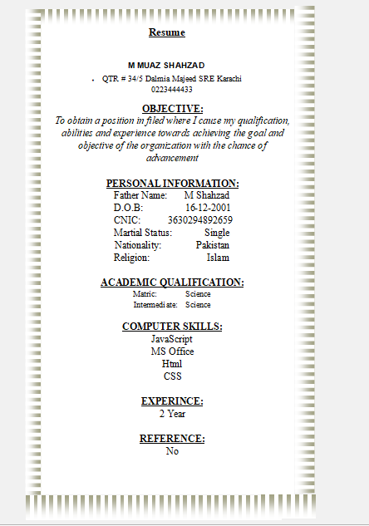

**Brochure:**